Hybrid integration with Edge integration Cell (EIC) on SAP Integration Suite
Edge Integration Cell is a hybrid runtime extension of the SAP Integration Suite that enables integration scenarios and API processing to run within a customer-managed, private Kubernetes environment—while still leveraging design, configuration, and monitoring from the cloud-based SAP Integration Suite.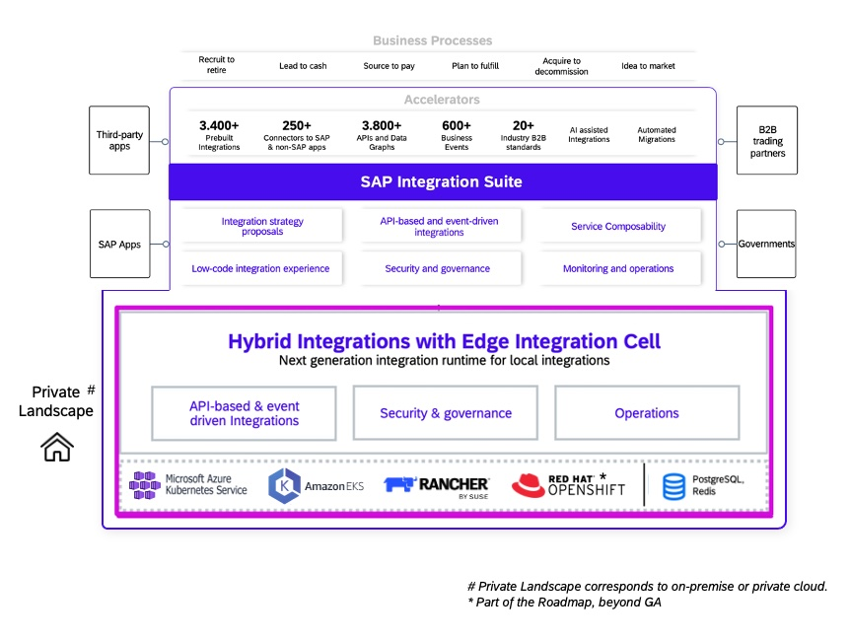

The runtime can be deployed on Azure AKS, Amazon EKS, Google GKE, SUSE Rancher, or RedHat OpenShift—supporting broad infrastructure flexibility.
Why Use Edge Integration Cell?
1. Data Sovereignty & Compliance
Keeps sensitive data within your private landscape, supporting governance and compliance mandates.
2. Hybrid Design & Monitoring
Design integration flows and APIs in the cloud-based SAP Integration Suite, deploy and run them at the edge.
3. Business Continuity & Resilience
EIC supports offline operation during internet outages—processing messages locally and synchronizing when connectivity resumes.
4. Migration Path from Legacy Systems
Offers a bridge for SAP PI/PO customers to adopt CPI workflows while keeping execution local.
5. API-Driven Integration
Supports API-led integration with API artifacts deployable to both cloud and edge environments; includes enhanced API management features like security and traffic routing.
6. Performance Benefits
Local runtime reduces latency and boosts performance for time-sensitive workloads.

Architecture & Components
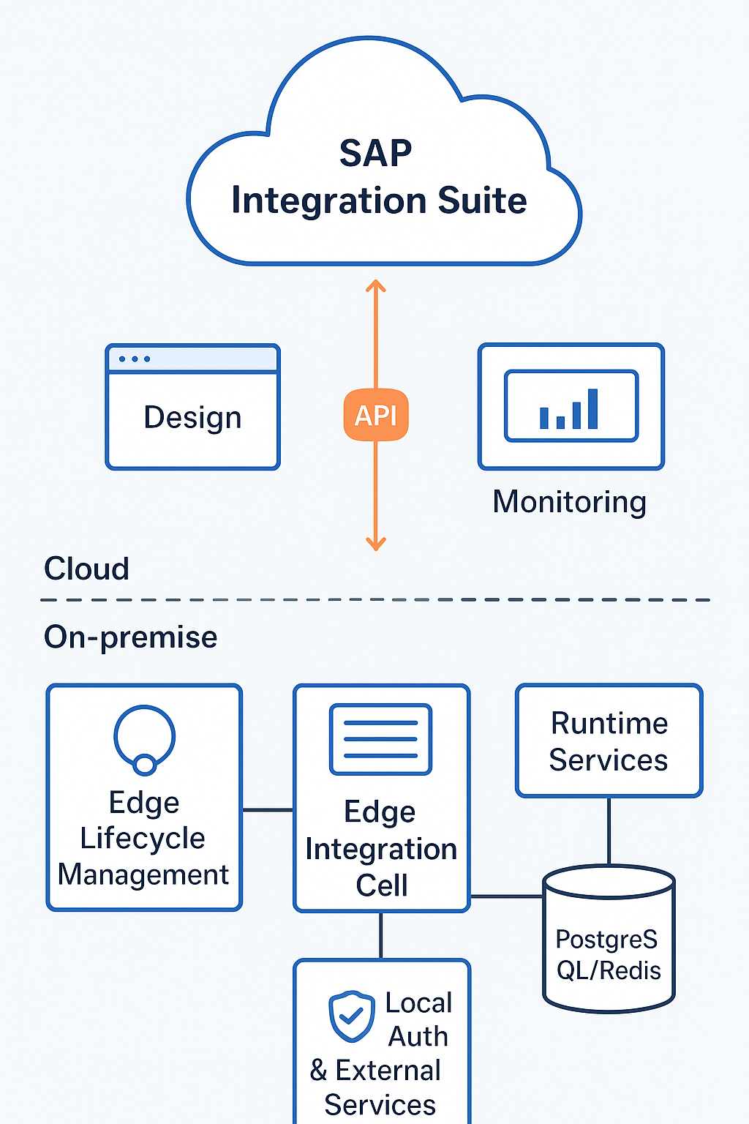

- Edge Lifecycle Management: Manages container shipments, upgrades, deployments, and includes an embedded Cloud Connector for secure tunnel setup.
- Runtime Services: Executes integration flows and API proxies locally.
- Local Auth & External Services: Supports local authentication and authorization; includes message handling (e.g., Solace Broker) and requires infrastructure components like Load Balancers, and optional services like PostgreSQL or Redis for persistence.
Personas & Tasks
There are mainly 3 personas involved with Edge Integration Cell.
First is the “System admin”, who takes care of provisioning and maintaining the K8s platform and clusters.
Second is the “Tenant admin”, who is responsible for setting up Edge Integration Cell, monitor, operate and manage upgrades.
And the third is the “Integration / API developer”, who is responsible for designing, deploying and executing APIs and integrations on Edge Integration Cell.
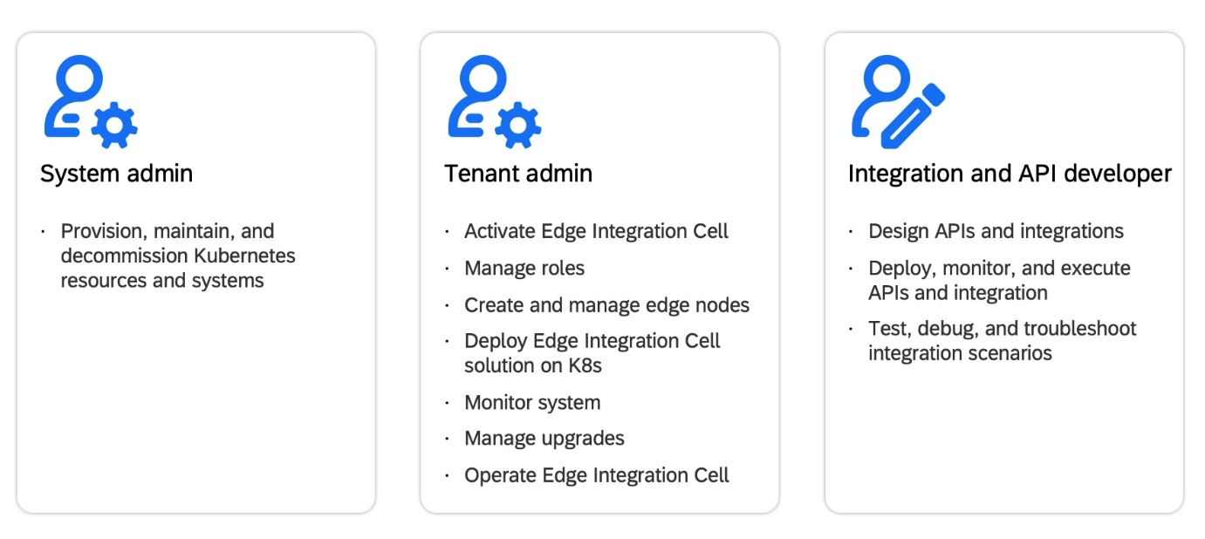
Deployment & Licensing
Deployment Steps:
- Ensure you have an SAP Integration Suite tenant with entitlement for EIC.
- Prepare a supported Kubernetes environment.
- Configure entitlements via the SAP BTP cockpit under the Integration Suite service to enable Edge Integration Cell.
https://community.sap.com/t5/integration-blog-posts/frequently-asked-questions-faq-on-edge-integration-cell/ba-p/13571636
- Use Edge Lifecycle Management to bootstrap the runtime on your cluster through service keys and Kubernetes config.
Licensing:
- Each Integration Suite tenant (Standard, Premium, CPEA, PAYG) includes one EIC entitlement.
- Additional edge runtimes are available via add-on SKUs.
- Only 50% of processed messages through EIC are chargeable (excluding SAP standard content).
Known Restrictions:
- Some features are not yet supported in EIC, such as: external logging, full access policies, B2B capabilities, partner directory, certain adapters, OAuth2 authorization code flows, and more.
Planned Enhancements:
- Improved offline support (e.g., 4-hour continuity), API & access policy parity, expanded adapter support (RFC Sender, OFTP2, File, X400), RedHat OpenShift support, and expanded API policy options and remote OData monitoring APIs.

References:
https://learning.sap.com/learning-journeys/migrating-to-sap-integration-suite/migration-to-sap-integratioin-suite-edge-integration-cell

